# **Name: Abdurrahman Qureshi**

# **Roll No: 210451**

Practical No: 8

1) Find largest and smallest from a tuple

CODE:

my_set = {1, 2, 3, 4, 5}  
print("Created set:", my_set)  
  
print("Accessing set elements:")  
for element in my_set:  
 print(element)  
  
my_set.add(6)  
print("Adding element 6 using add() method:", my_set)  
  
my_set.update([7, 8, 9])  
print("Updating set with elements [7, 8, 9] using update() method:", my_set)  
  
my_set.discard(5)  
print("Discarding element 5 using discard() method:", my_set)  
  
my_set.remove(4)  
print("Removing element 4 using remove() method:", my_set)  
  
my_set.clear()  
print("Clearing the set using clear() method:", my_set)

OUTPUT:

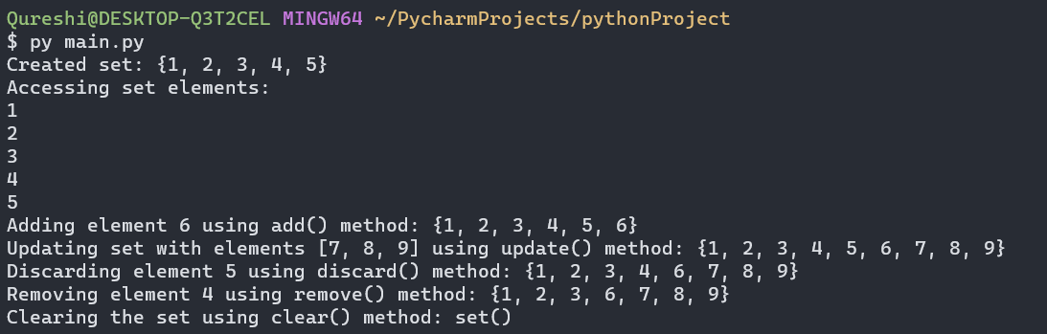

2) Write a Python program to perform following operations on set: intersection of sets, union of sets, set difference, symmetric difference, clear a set.

**CODE:**

a = {1, 2, 3}  
b = {4, 5, 1}  
c = {6, 7, 2}  
  
intersection_result = a.intersection(b)  
print("Intersection of sets a and b:", intersection_result)  
  
union_result = a.union(c)  
print("Union of sets a and c:", union_result)  
  
difference_result = a.difference(b)  
print("Set difference of sets a and b:", difference_result)  
  
symmetric_difference_result = a.symmetric_difference(b)  
print("Symmetric difference of sets a and b:", symmetric_difference_result)  
  
a.clear()  
print("Set 'a' after clearing:", a)

**OUTPUT:**

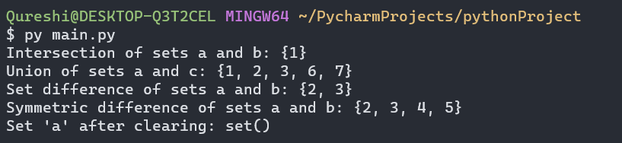

3) Write a Python program to find maximum and the minimum value in a set.

CODE:

a={1,2,3,22,21,40,12}  
print ("set A=",a)  
print("Maximum of set A:", max(a))  
print("Minmum of set A:", min(a))  
print("Length of set A:", len(a))

**OUTPUT:**

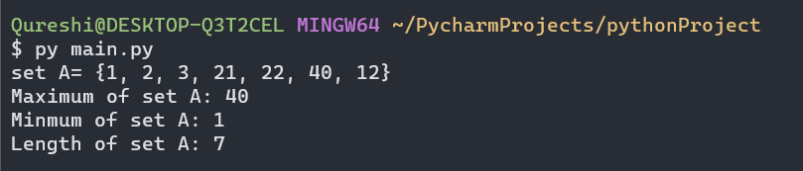

4) Write a Python program to find the length of a set.

**CODE:**

a={1,2,3,22,21,40,12}  
print ("set A=",a)  
print("Length of set A:", len(a))

**OUTPUT:**

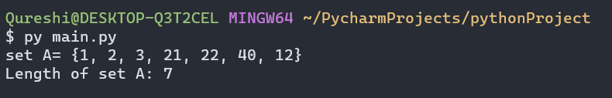

5) Create a set. Demonstrate the use of the remove and discard method.

CODE:

my_set = {1, 2, 3, 4, 5}  
print("Created set:", my_set)  
  
print("Accessing set elements:")  
for element in my_set:  
 print(element)  
  
my_set.add(6)  
print("Adding element 6 using add() method:", my_set)  
  
my_set.update([7, 8, 9])  
print("Updating set with elements [7, 8, 9] using update() method:", my_set)  
  
my_set.discard(5)  
print("Discarding element 5 using discard() method:", my_set)  
  
my_set.remove(4)  
print("Removing element 4 using remove() method:", my_set)  
  
my_set.clear()  
print("Clearing the set using clear() method:", my_set)

OUTPUT:



6) Remove a random element from a set

CODE:

a={1,2,3,22,21,40,12}  
print(a)  
rem = a.pop()  
print(a)

OUTPUT:

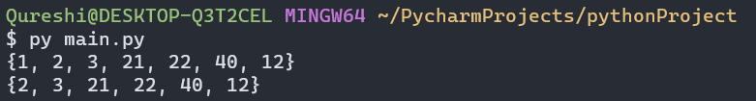

7) Create a frozen set.

CODE:

a={1,2,3,22,21,40,12}  
b = frozenset(a)  
print(a)  
print(b)

OUTPUT:

